*Train Simulation*

Use Case Specification Document

**Case Id 2**

**Add/Remove Trains**

Version No. 2.0.0

Project Document Revision History

|  |  |  |  |
| --- | --- | --- | --- |
| **VersionNumber** | **Date** | **Revision Author** | **Description of Revision** |
| 1.0 | 3/15/2019 | Brendan Batchelor | Brendan Batchelor completed:  1.) Introduction  2.) Use Case Information  3.) Trigger  4.) Preconditions  5.) Postconditions  6.) Use Case Swimlane (Activity) Diagram  7.) Main/Basic Flow(s) of Events (Happy Path)  8.) Alternate/Exception Flow of Events  9.) Assumptions/Business Rules including Non-Functional Requirements  10.) Use Case Specification Review and Signoff |
| 1.0.1 | 3/18/2019 | Brendan Batchelor | Added Project document revision history  Removed 10.  Added TOC page numbers |
| 2.1.0 | 4/18/2019 | Zaid Alsafi | Edit and revise any assumption added in the document. |

Table of Contents

**1. Introduction** **4**

**2. Use Case Information** **4**

2.1 Actors 4

2.2 Use Case Interaction 4

**3. Trigger** **5**

**4. Pre-condition(s)** **5**

**5. Post-Condition(s)** **5**

**6. Use Case Swimlane Diagram** **6**

**7. Main/Basic Flow(s) of Events** **7**

**8. Alternative/Exception Flow of Events** **7**

**9. Assumptions/Business Rules including Non-Functional Requirements** 7

# 1. Introduction

User will be able to add or remove trains from the railroad simulation. This will be done before each simulation is run. In the creation of new locomotives, train type, starting hub, and ~~capacity~~ must be chosen by the user.

# 2. Use Case Information

## 2.1 Actors

|  |  |  |
| --- | --- | --- |
| **Actor Name** | **Role** | **Description** |
| User | Main Actor | Engages train editing and decides what changes are made. |
| Simulation System | Secondary Actor | Rejects invalid change attempts, saves all changes upon exiting. |

## 2.2 Use Case Interaction

**A list of predecessors use cases are as follows:**

Case 1: Setup Initial State – To reach the editing stage of the program, a railroad must be loaded and the simulation must be ran at least one time.

Case 3: Edit Railway– In order to assign a train to a starting hub, the railway layout must be complete.

Case 5: Update Graph – Done after case 3.

Case 4: Adjust Weather Options – Both successor and predecessor. Part of case 6.

Case 6: Run Simulation – Must happen once before train editing is unlocked.

Case 7: Track Statistics – See above. Statistics may be used during editing by user.

Case 8: Recommend Changes – Must happen once before train editing is unlocked.

Case 9: View Statistics – Optional. User is advised to do this step before editing.

**A list of successors use cases are as follows:**

Case 10: Rollback Simulation History – This is the final step in the program, it logically comes after all other use cases.

# 3. Trigger

The use case is triggered when the user finishes editing the railway. The choice to modify how many and which types of trains will be present in which hubs before starting the next simulation.

# 4. Pre-condition(s)

**4.1:** First simulation must have been completed

**4.2:** User must have ended the railway editing phase prior to editing trains

**~~4.3:~~** ~~Print error message if last train is chosen for deletion~~

# 5. Post-Condition(s)

**5.1:** After the user has finished editing trains, they may begin the next simulation or tweak other settings prior to starting it.

**5.2:** The user may edit trains again anytime before the simulation starts

**5.3:** Print error message if last train is chosen for deletion

# 6. Use Case Swimlane Diagram

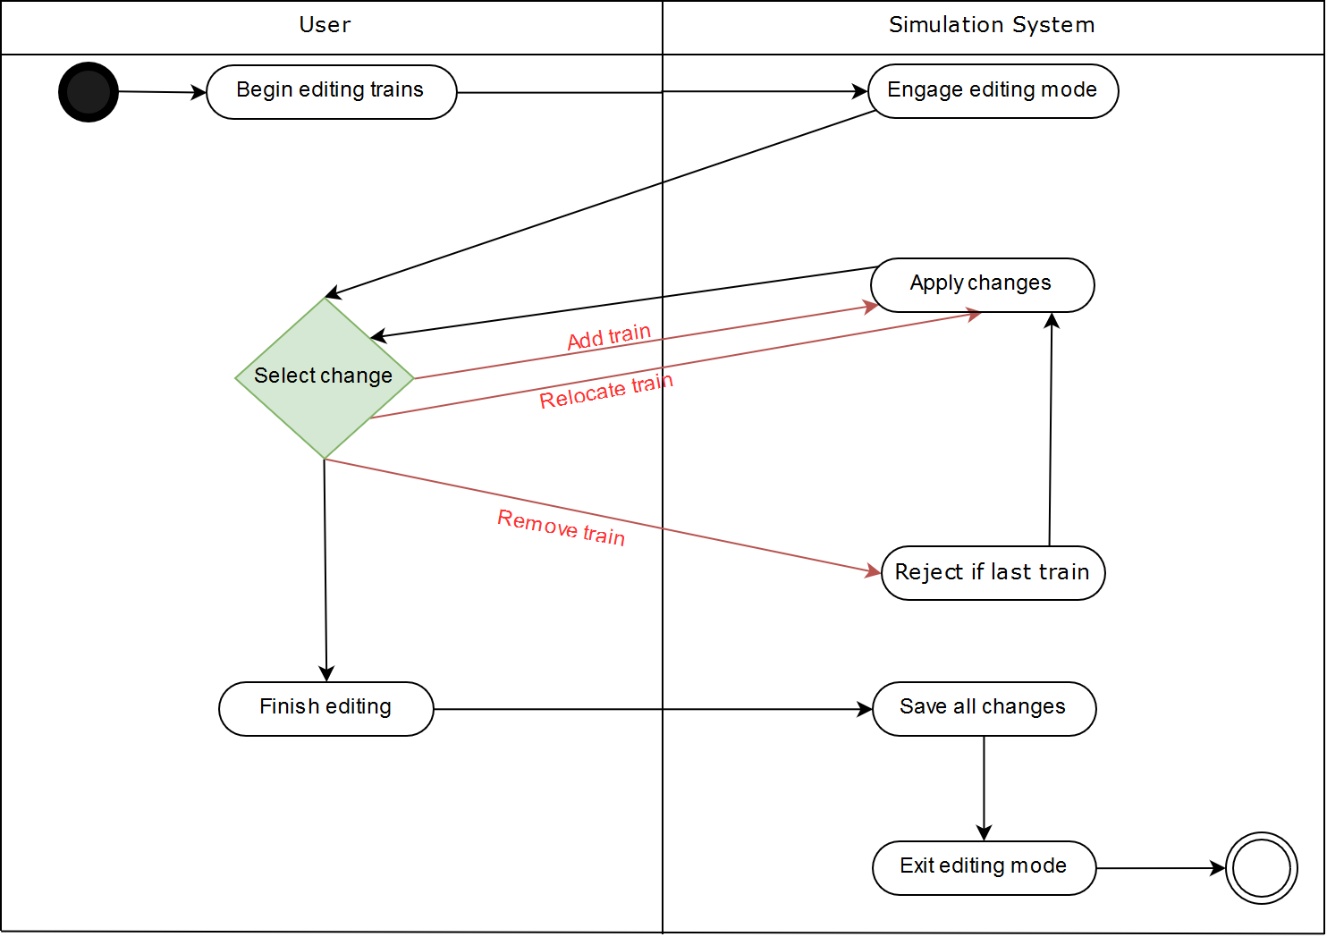

# 

# 7. Main/Basic Flow(s) of Events

**7.1:** Finish editing railroad and choose to edit trains.

**7.2:** User may choose to add, remove, or relocate trains.

**7.2.1:** Add: User chooses a type of train to create and where it will spawn (which hub). In freight trains, ~~user will also choose the train capacity.~~

**7.2.2:** Remove: User chooses an existing train to delete

**7.2.3:** Relocate: User chooses an existing train to move to a different hub

**7.3:** User exits train editing mode.

# 8. Alternative/Exception Flow of Events

**8.1:** Number of trains must be at least 1

**8.2:** Train must be assigned hub and train type before it can be added

# 9. Assumptions/Business Rules including Non-Functional Requirements

**9.1:** N/A